Working through the wish list entry for **merge** Function

**Signature, purpose, and stub**

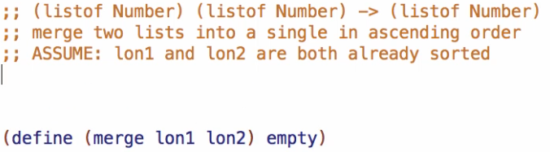

**Examples**

Simple cases

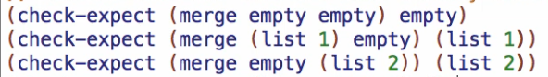

Longer cases



Working through the wish list entries for both **take** and **drop** Function

**Signature, purpose, and stub**



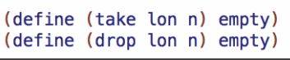

**Examples**

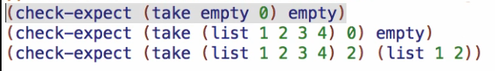

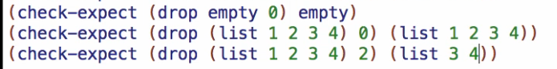

Finishing **merge** Function

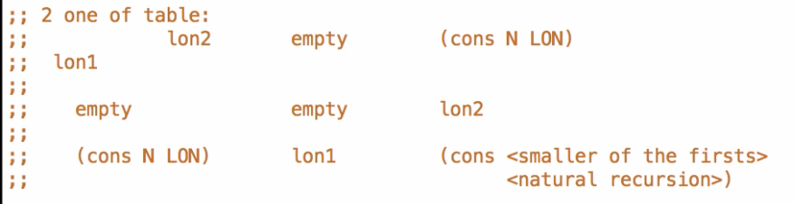

* 4 case table
* But empty can be equal to lon2 (empty) when both lon1 and lon2 are empty

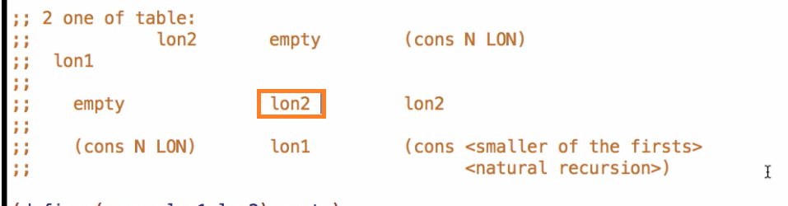

* So it becomes a 3 case table

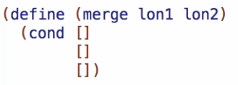

First case:

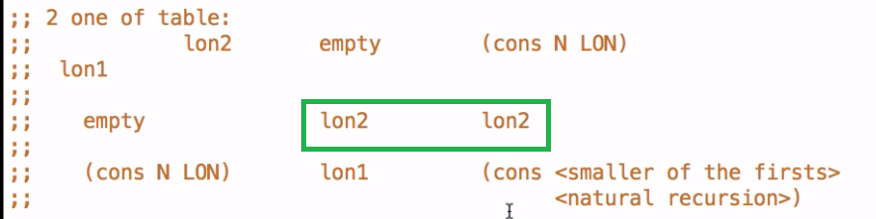

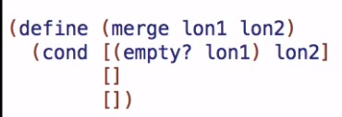

2nd case:

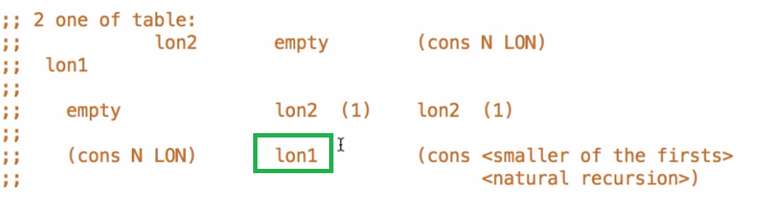

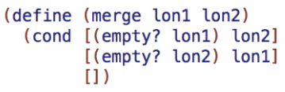

3rd case:

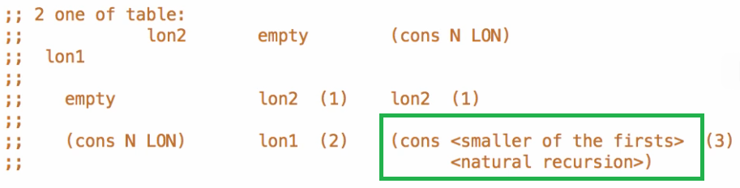

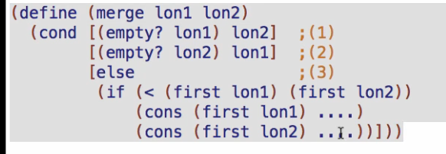

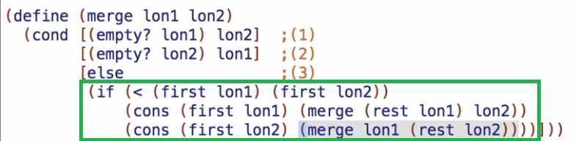

Working through **take** and **drop**

* There are functions in racket/list package for take and drop so we can now comment out the wish list for it
* Require that package
* 

Run and debug!